**Day 13 Results**

**HFOV requirement is 100mm**

**Important parameter considerations**

HFOV = 100mm

|  |  |  |  |  |  |
| --- | --- | --- | --- | --- | --- |
|  | h (mm) | Pixel width (um) | f (mm) | Pixel number | Example |
| Smartphone | 10 | 1.4 | 26.6 | 12mp  4032x3024 | Samsung s7  £150 |
| Compact camera | 15 | 2.1 | 28-105 (35mm equivalent)  6-22.5 | 10mp  3648x2736 | Canon Powershot S95  £394 |
| Reduced frame | 23.6x15.8 | 5.5 | 36-105 (equivalent)  24-70 | 12.3mpi  4288x2848 | Nikon D300  £150 |
| Full frame | 35  36.0x23.9 | 8.4 |  | 12.1mp  4256x2832 | Nikon D700  £424 used |
| Medium format | 44 | 5.3 |  | 50mp | Pentax 645Z |

<https://www.ephotozine.com/article/complete-guide-to-image-sensor-pixel-size-29652#:~:text=Pixel%20size%20ranges%20from%201.1,1mm%20x%201mm%20in%20size>

**Smartphone** h = 10mm, pixelWidth = 1.4um, minError = 35.7211um

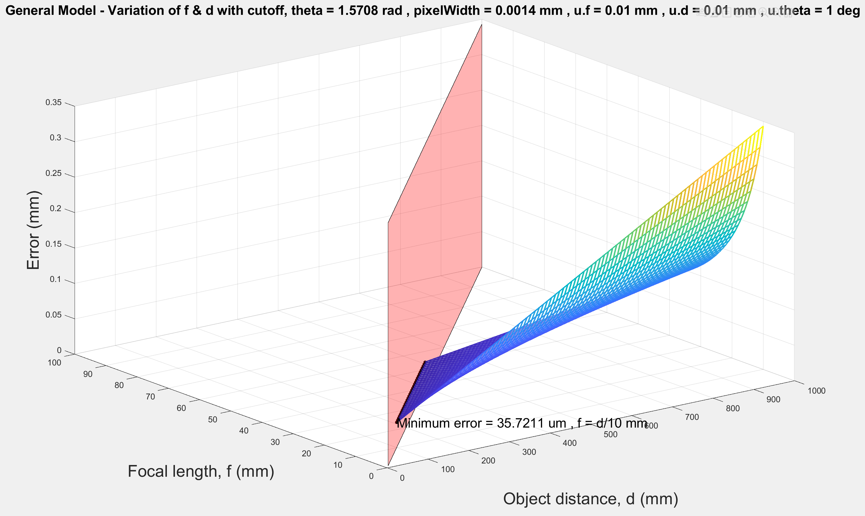

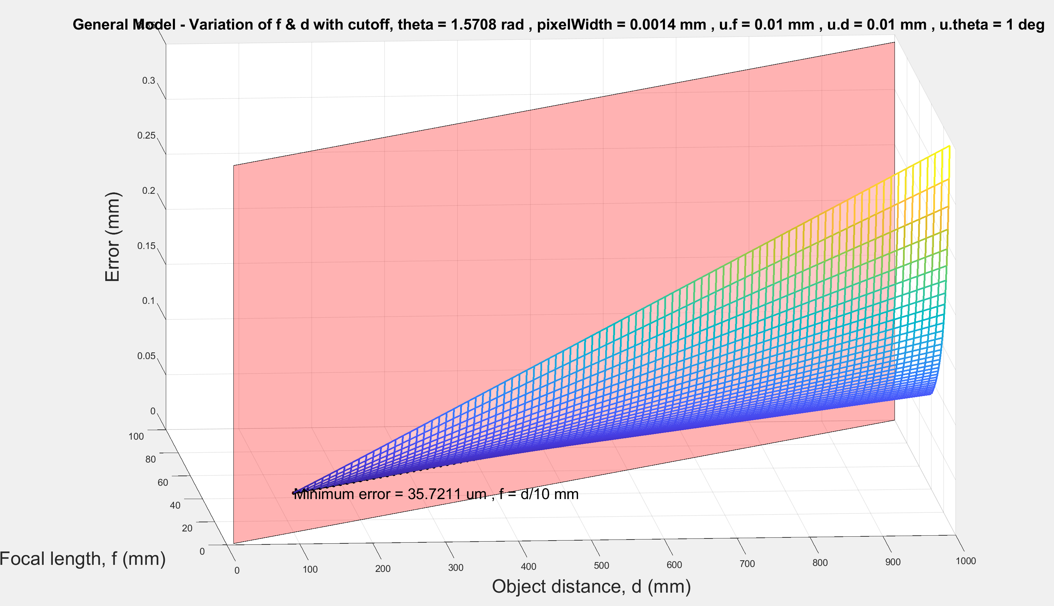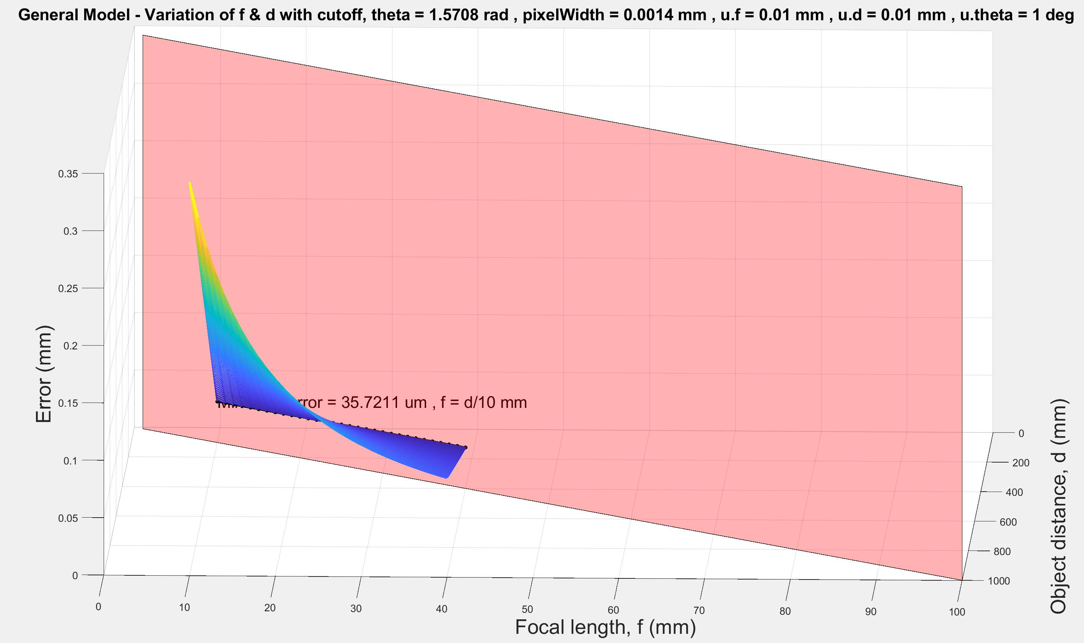

**Compact camera** h = 15mm, pixelWidth = 2.1um, minError = 35.7211um

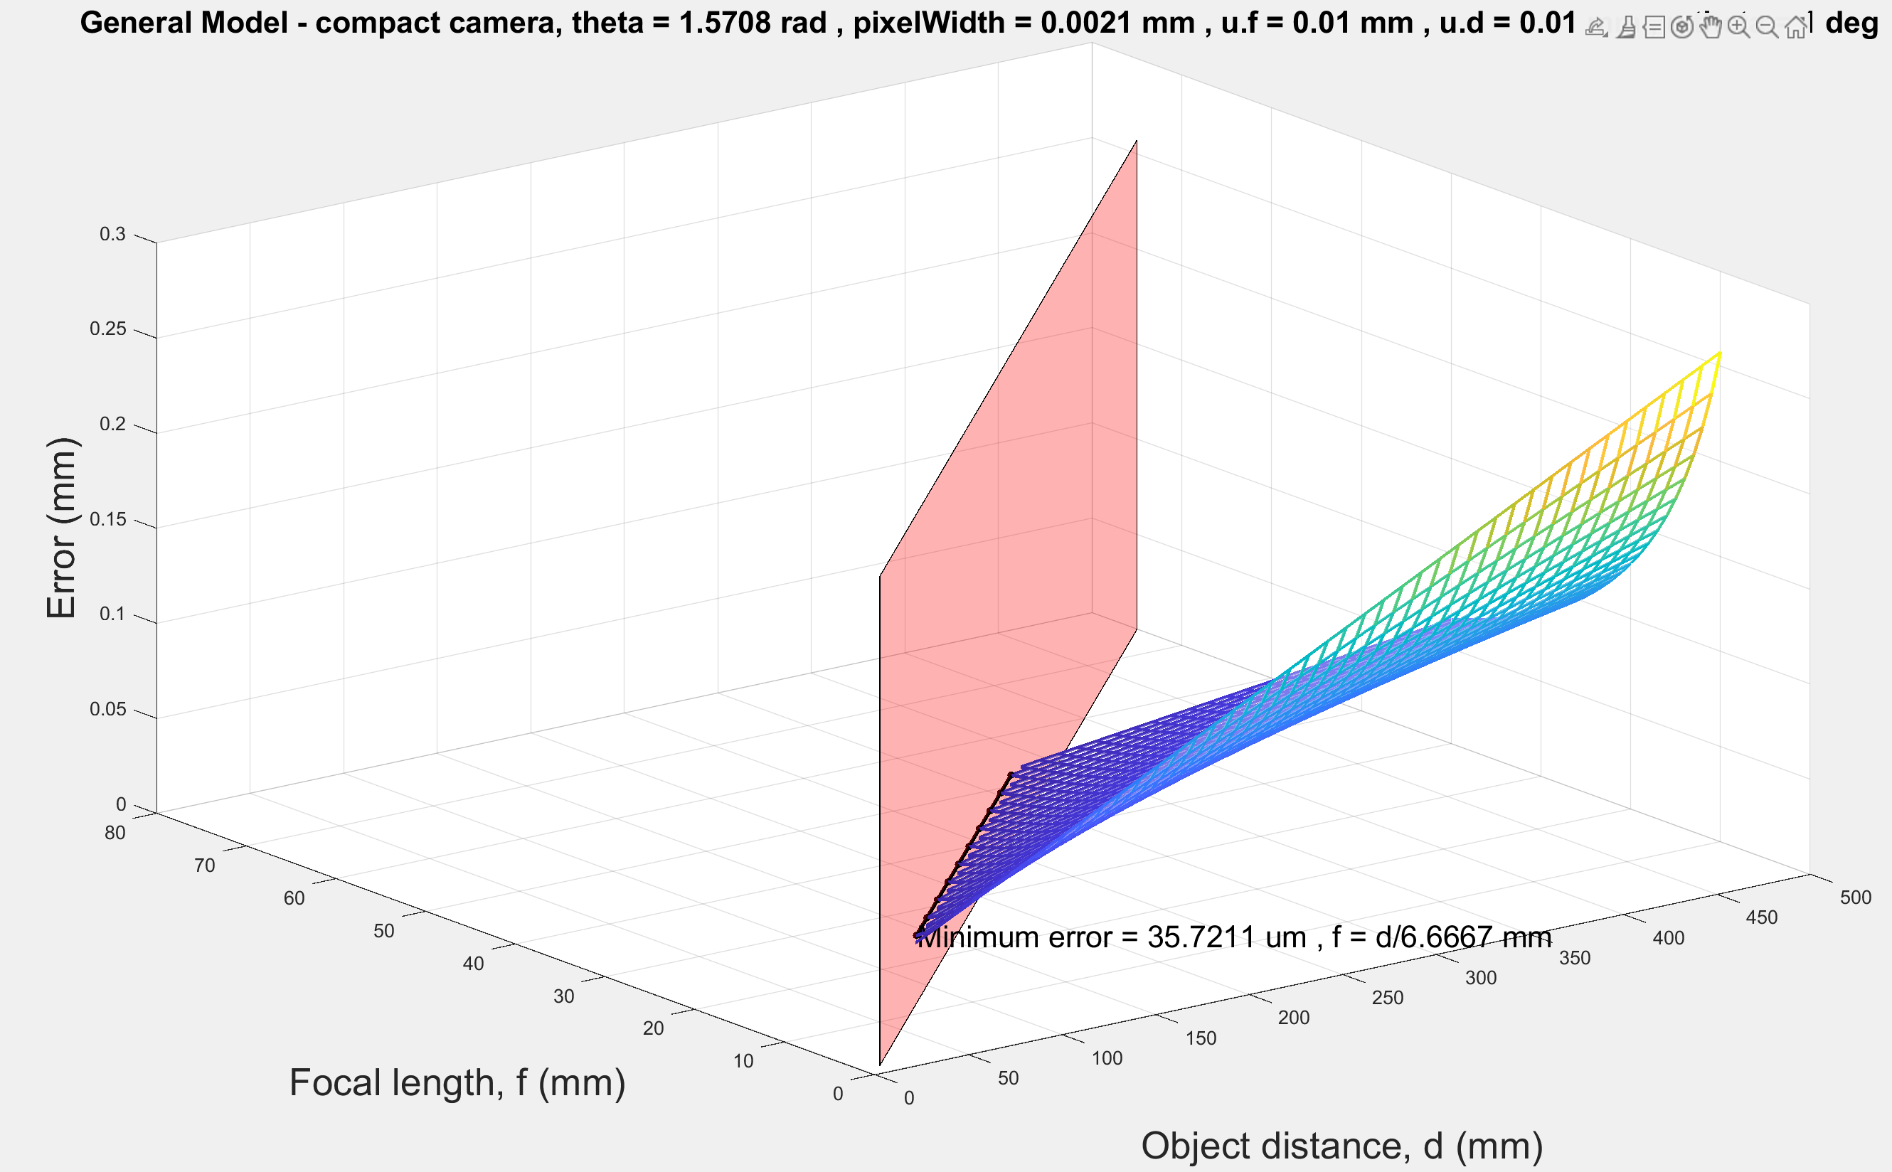

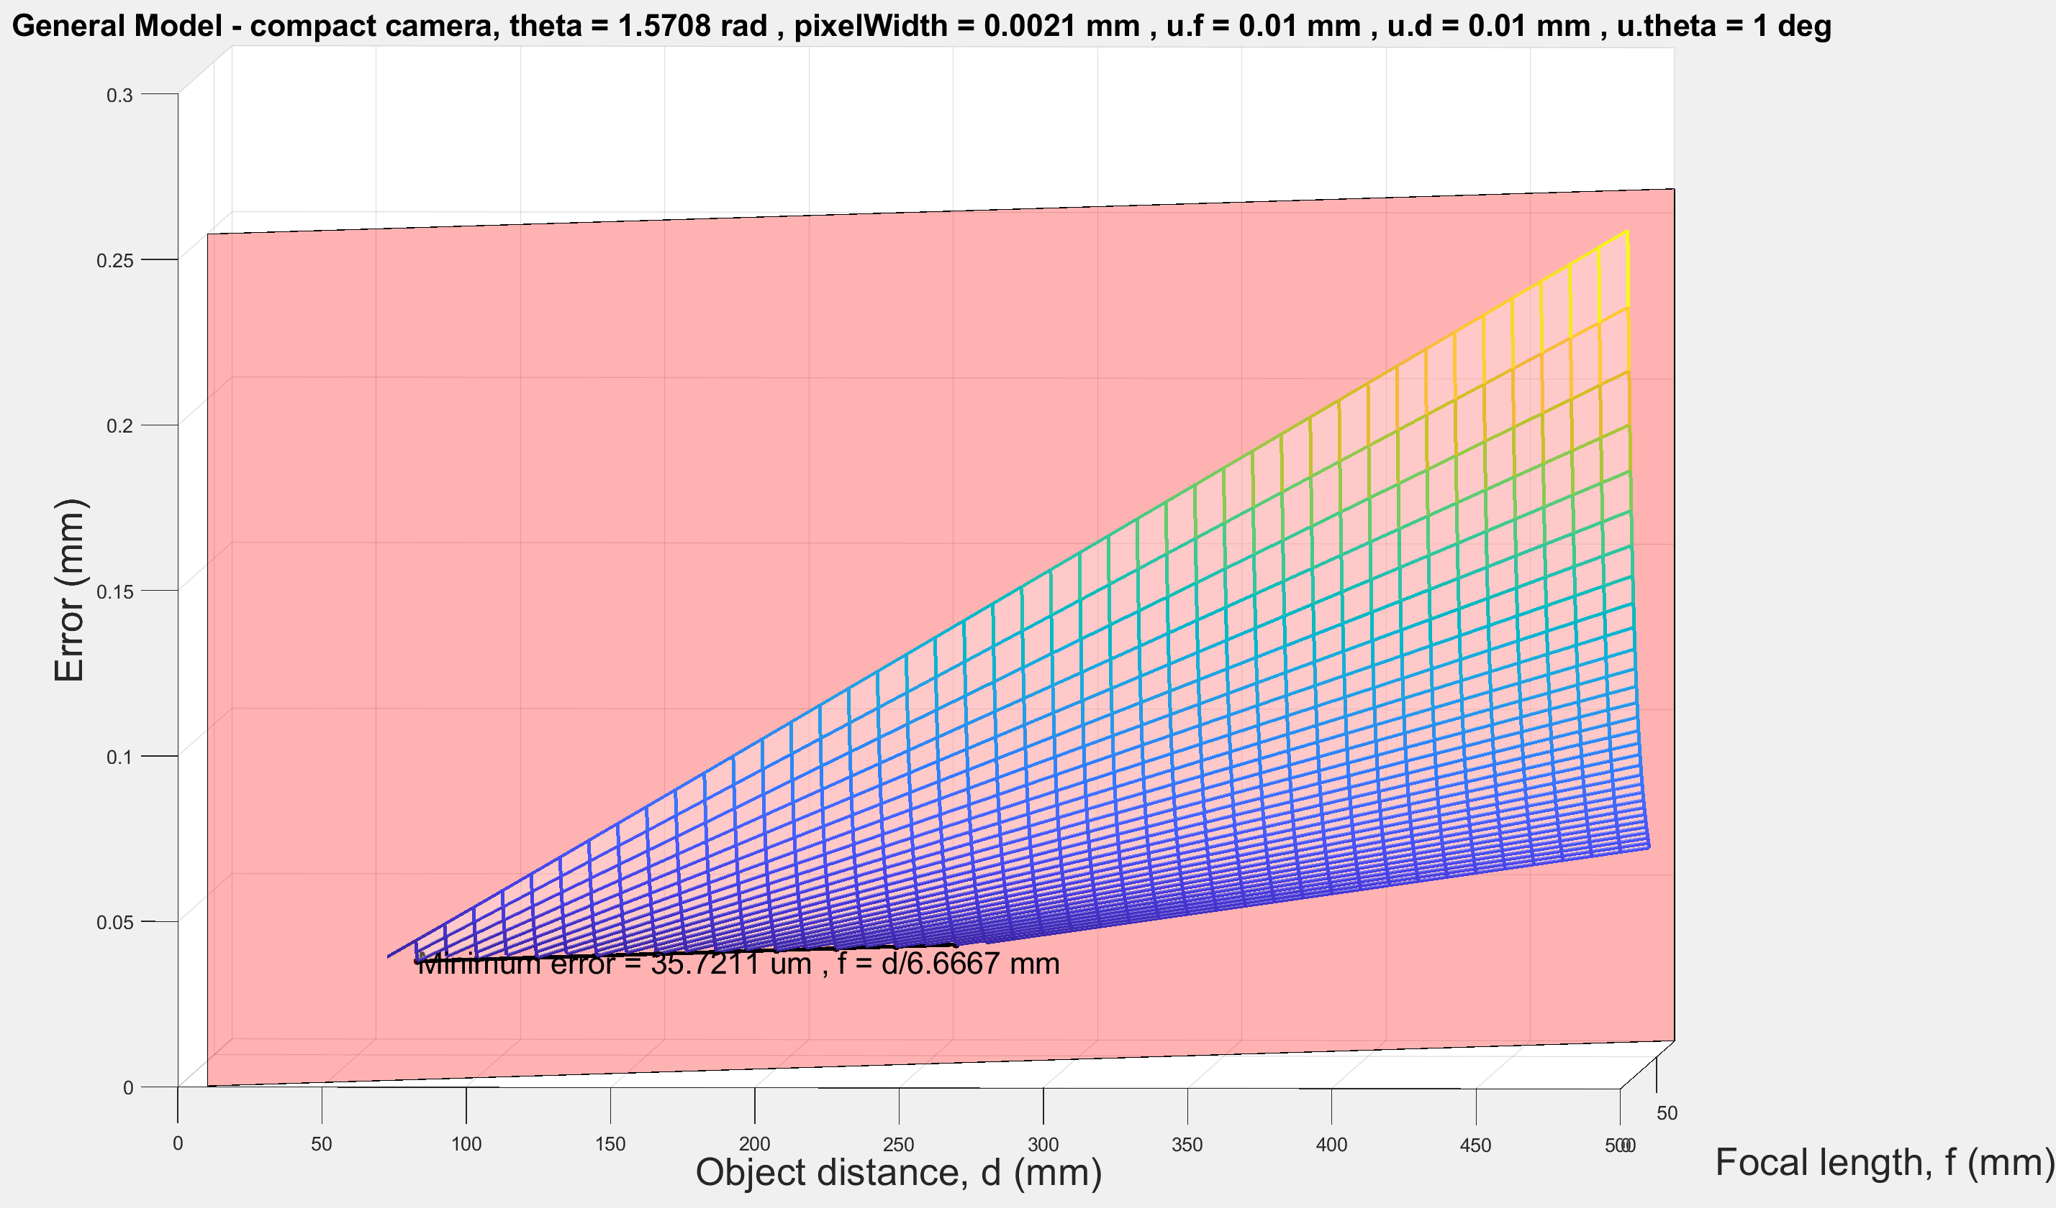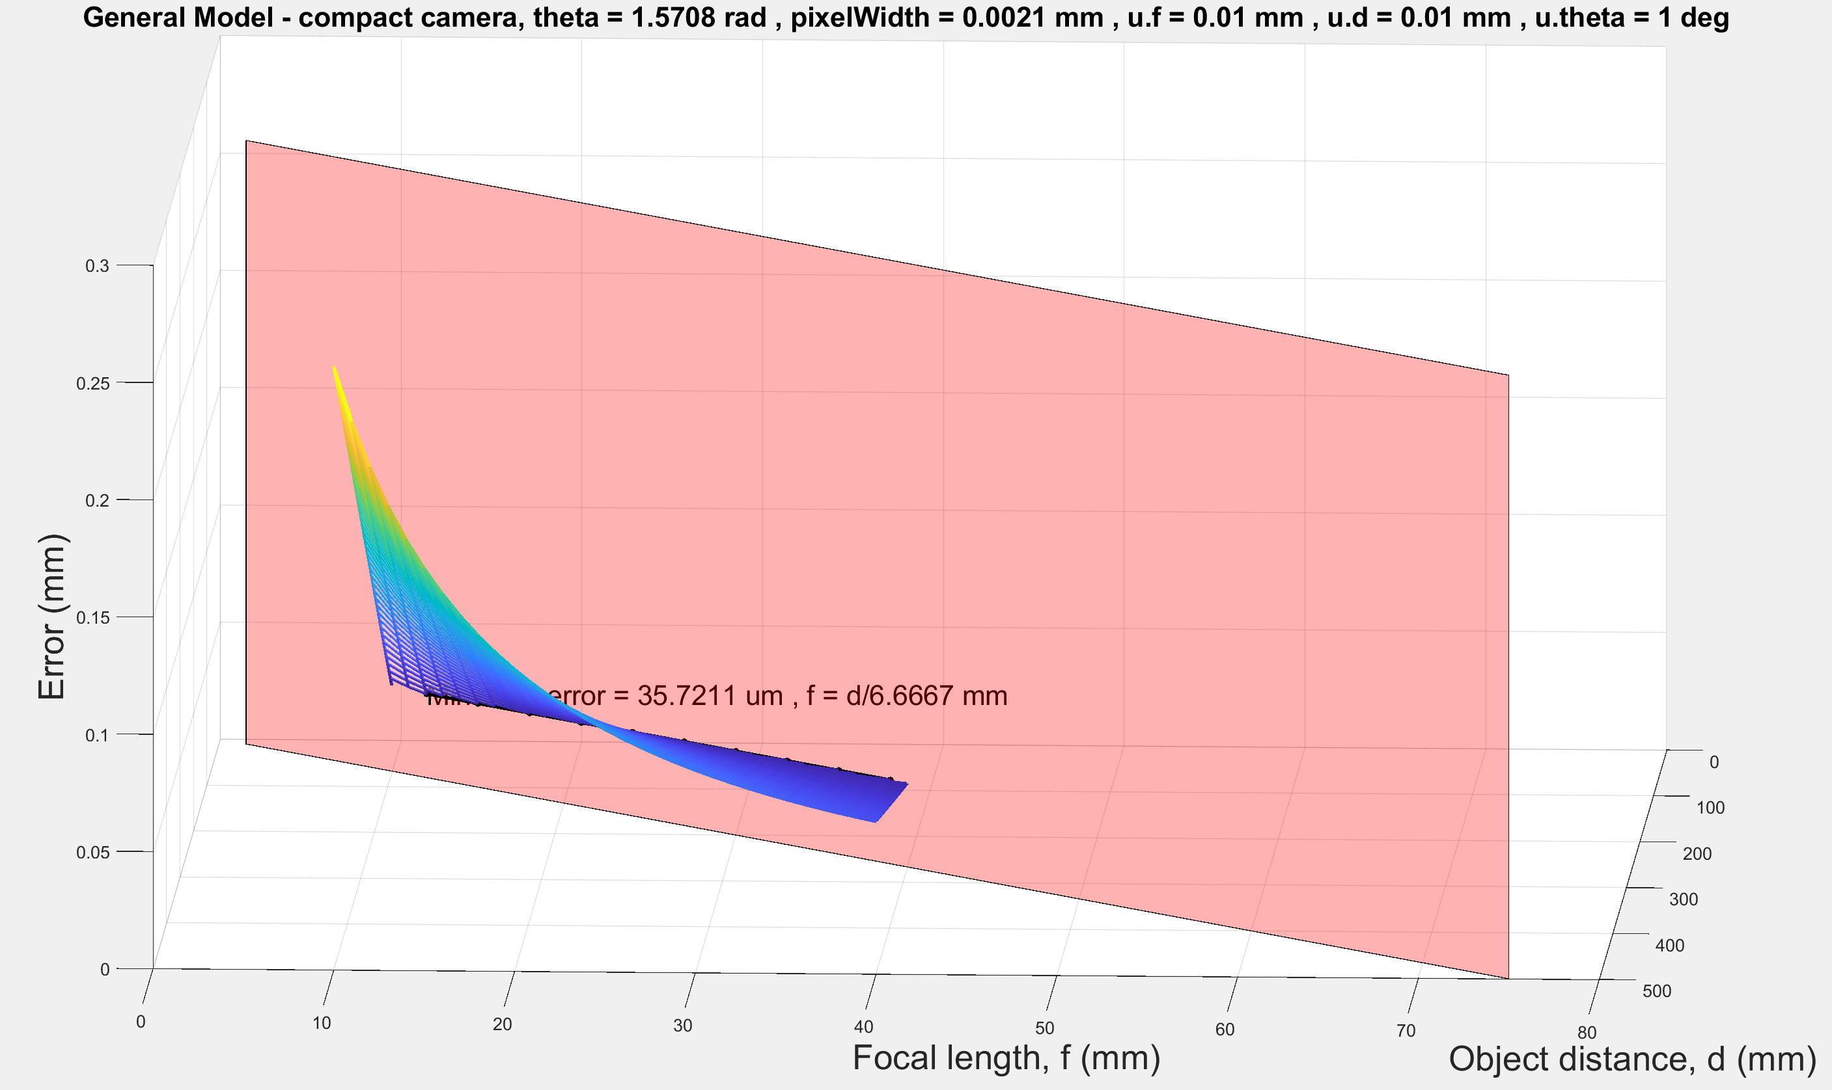

**Reduced frame** h = 24mm, pixelWidth = 5.5um, minError = 57.0179um

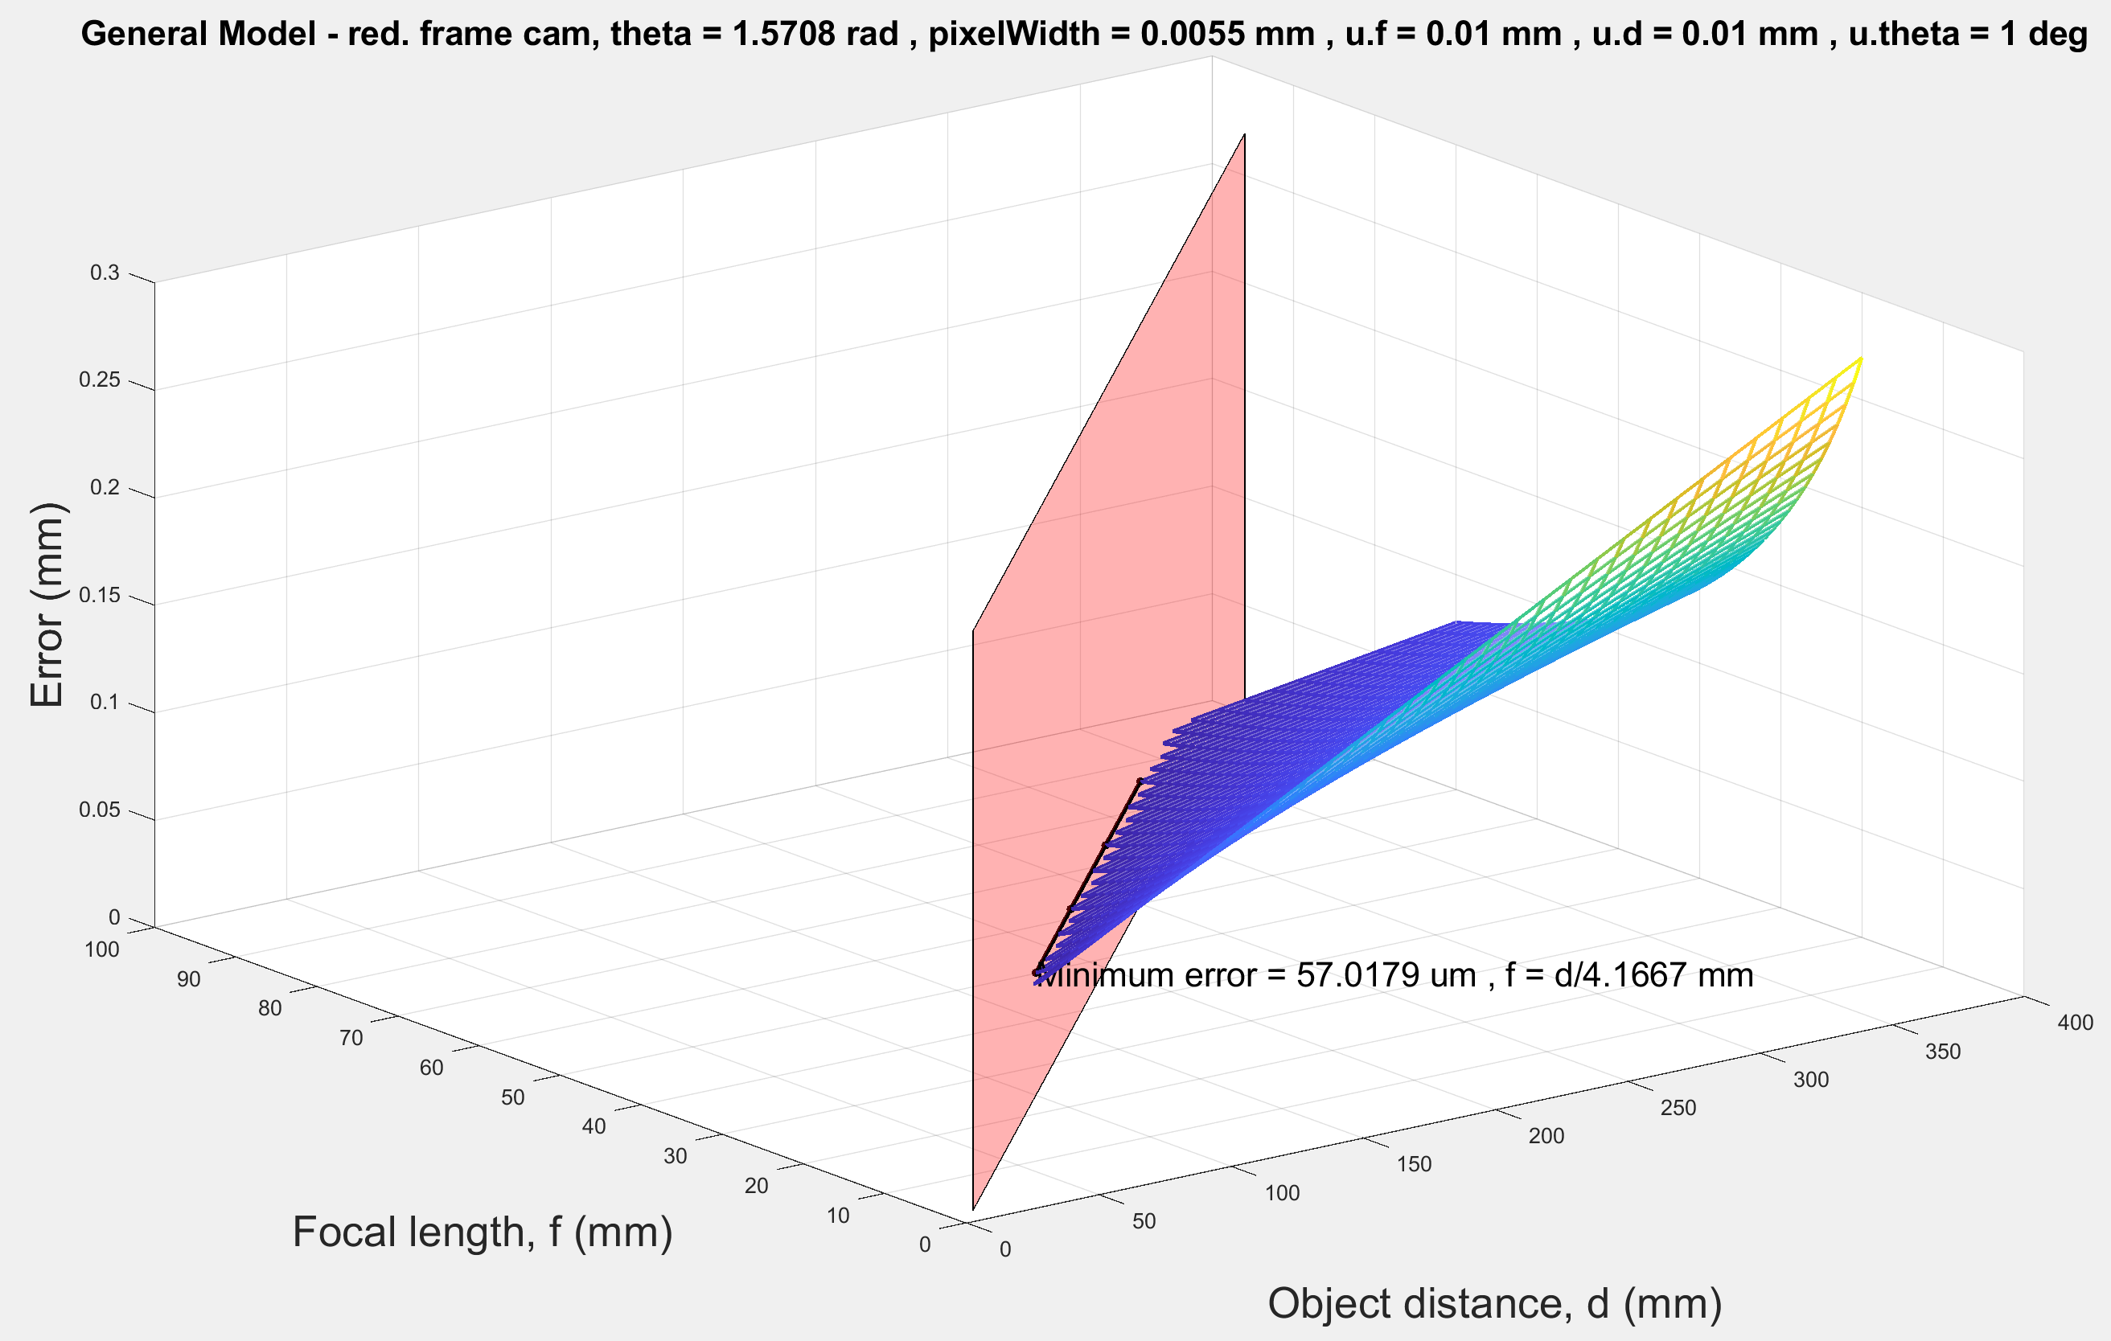

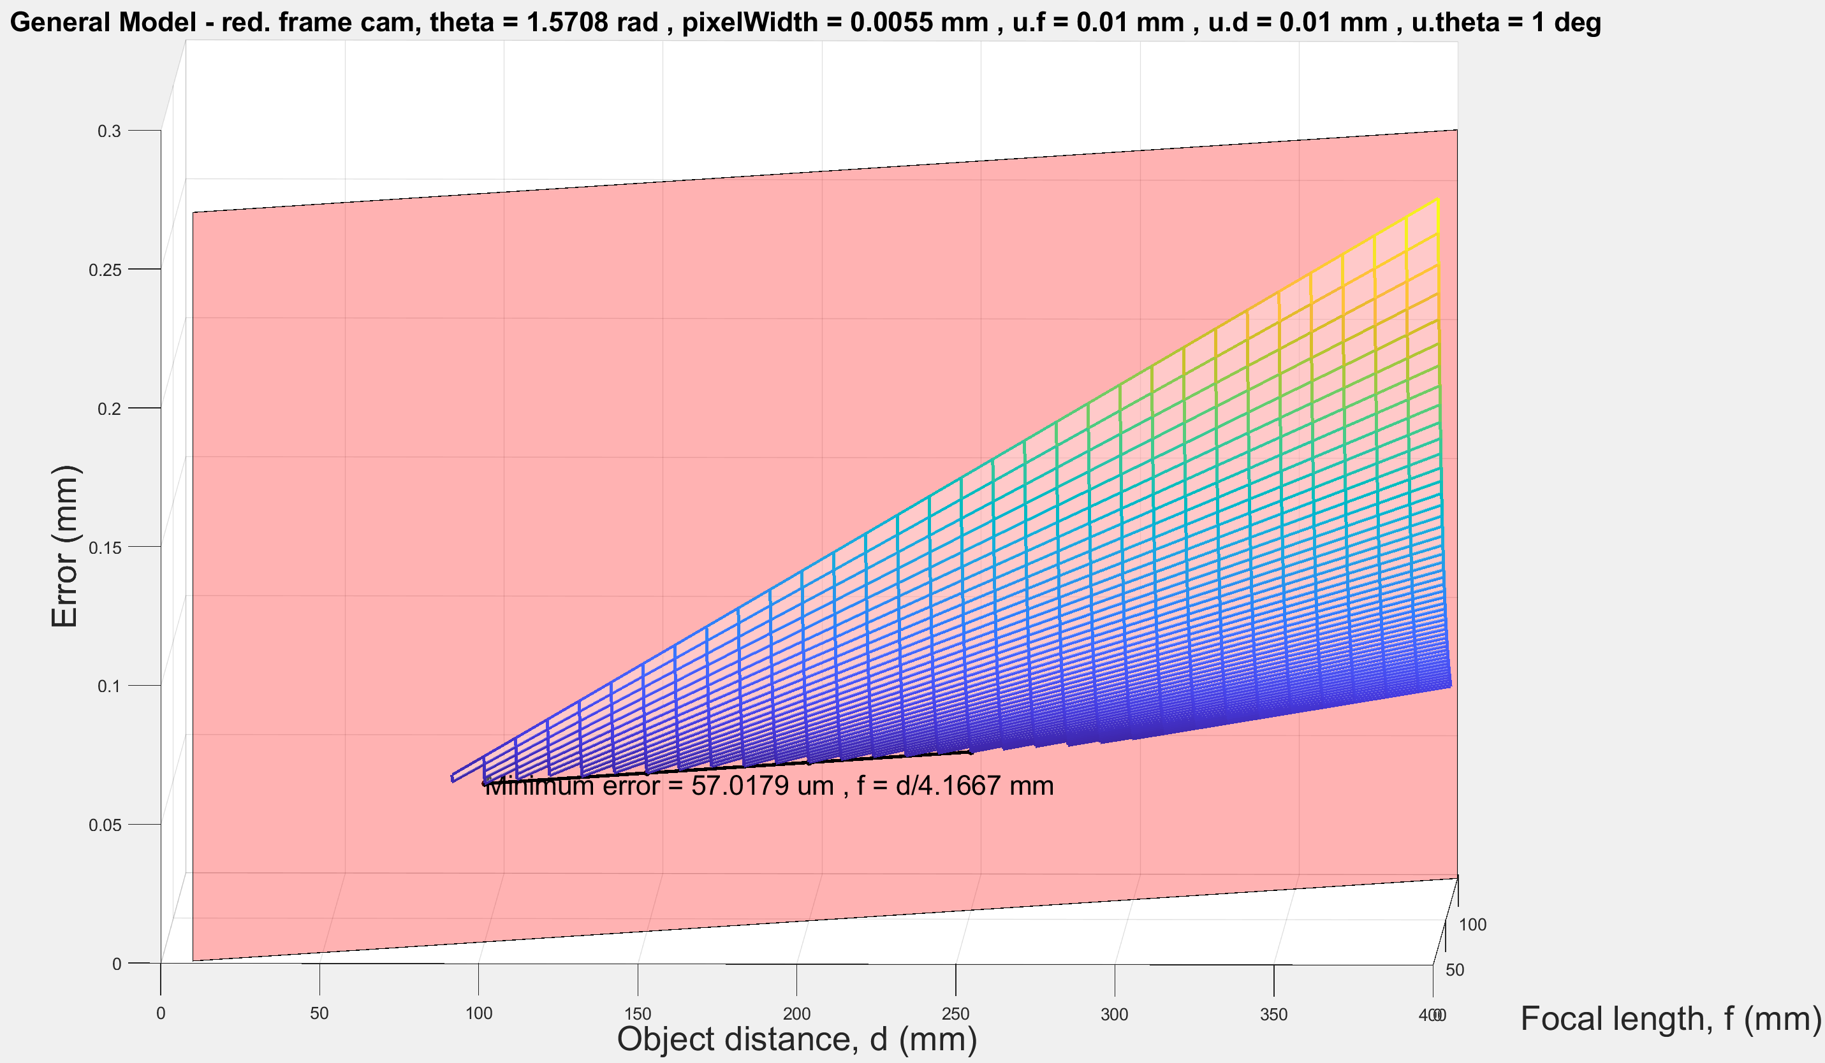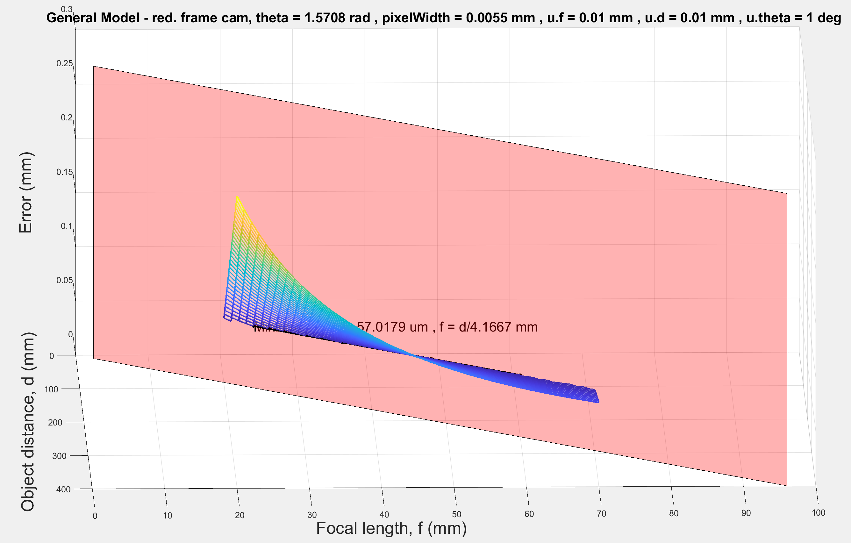

**Full frame** h = 35mm, pixelWidth = 8.4um, minError = 59.6322um

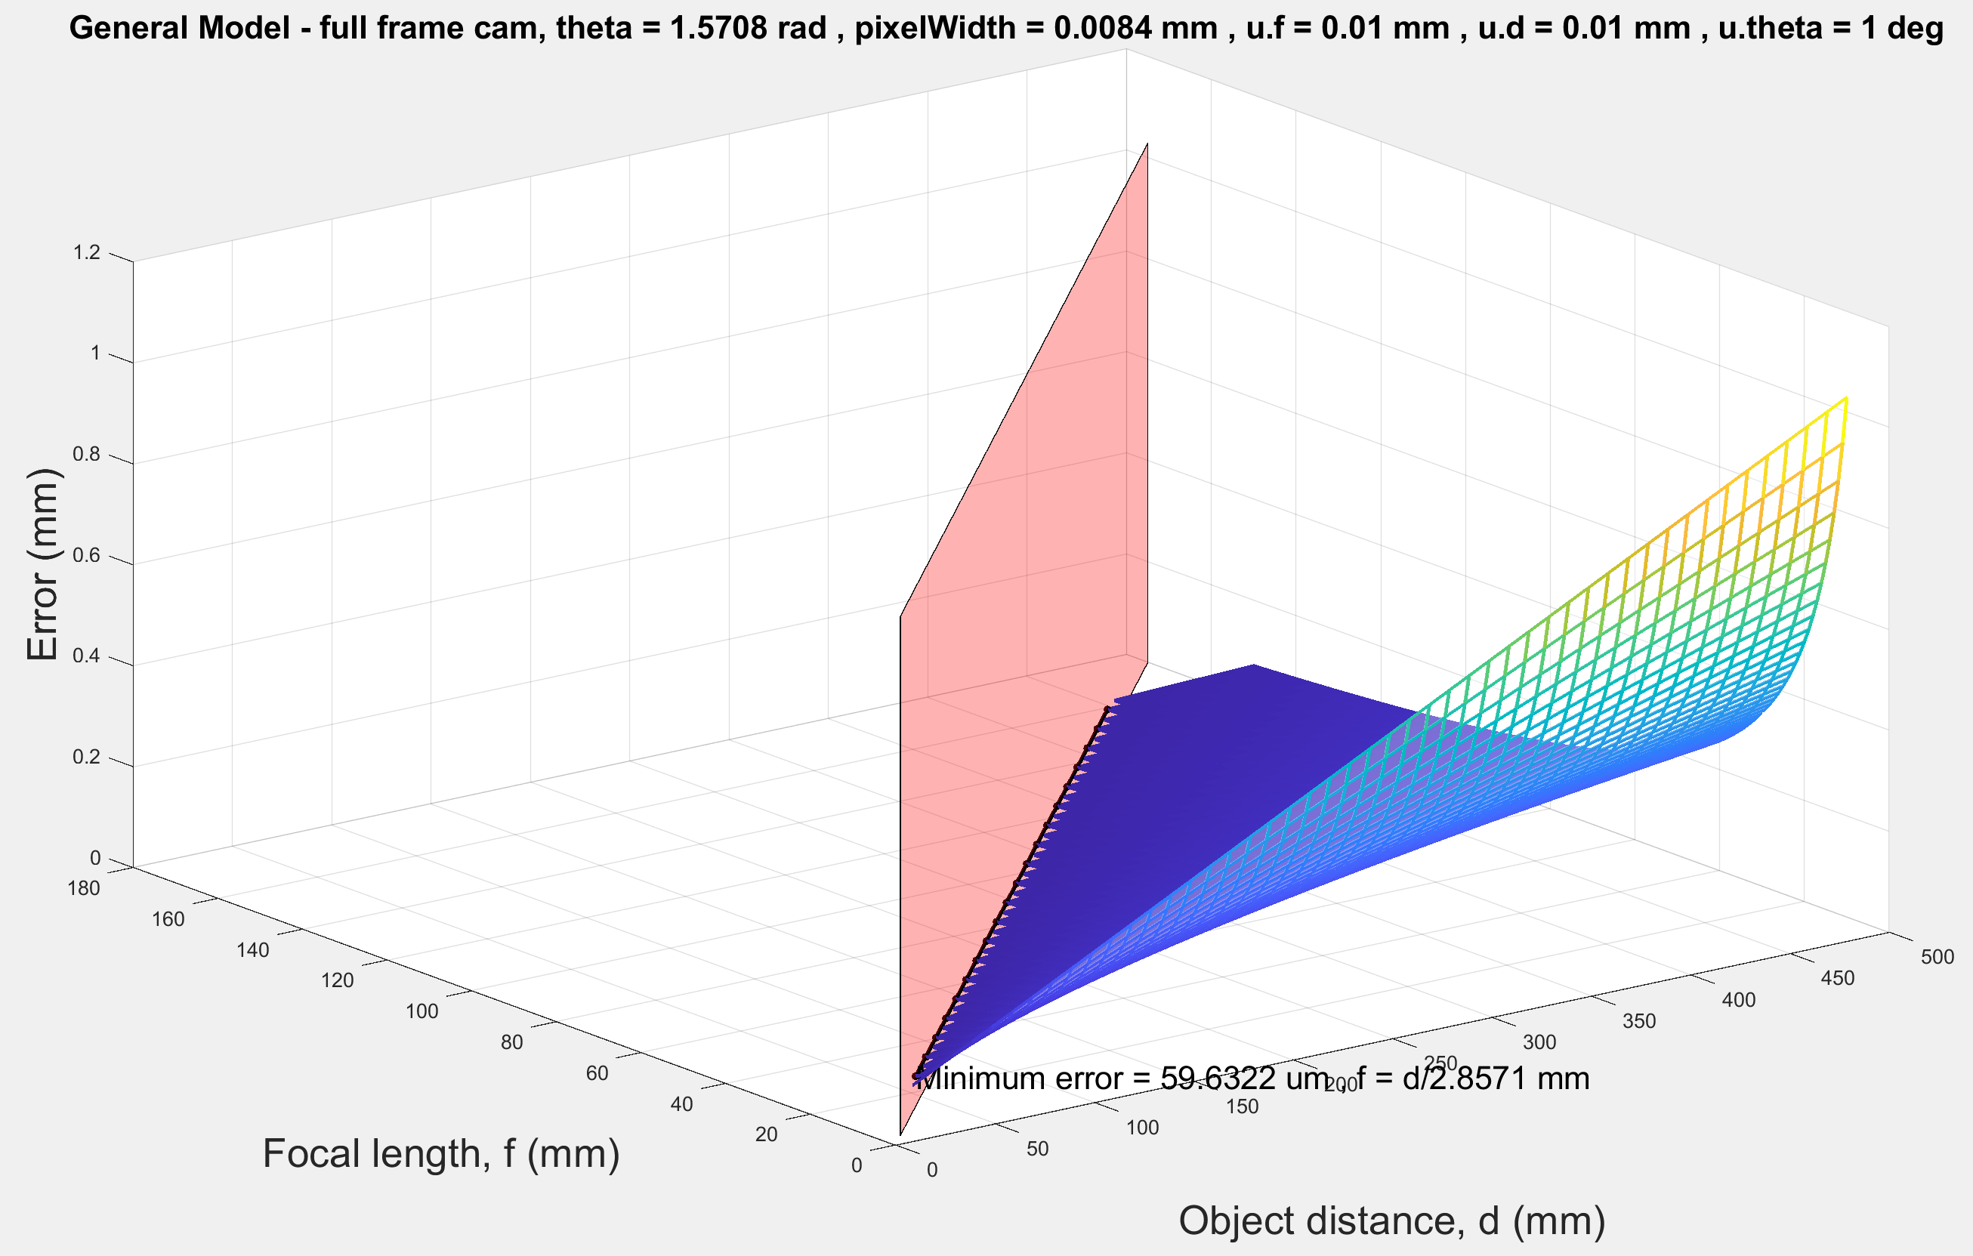

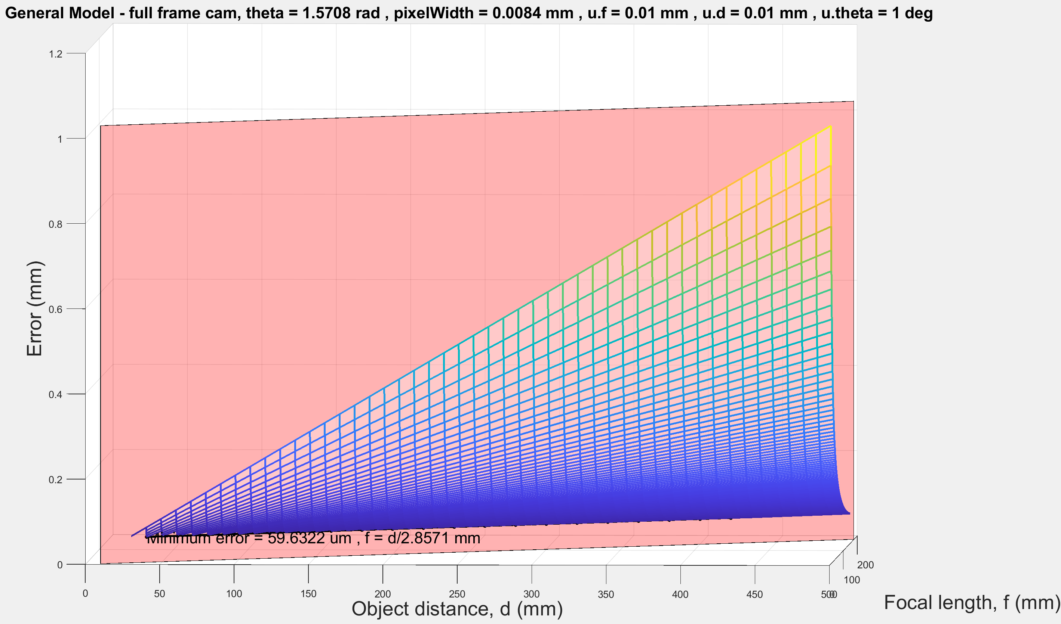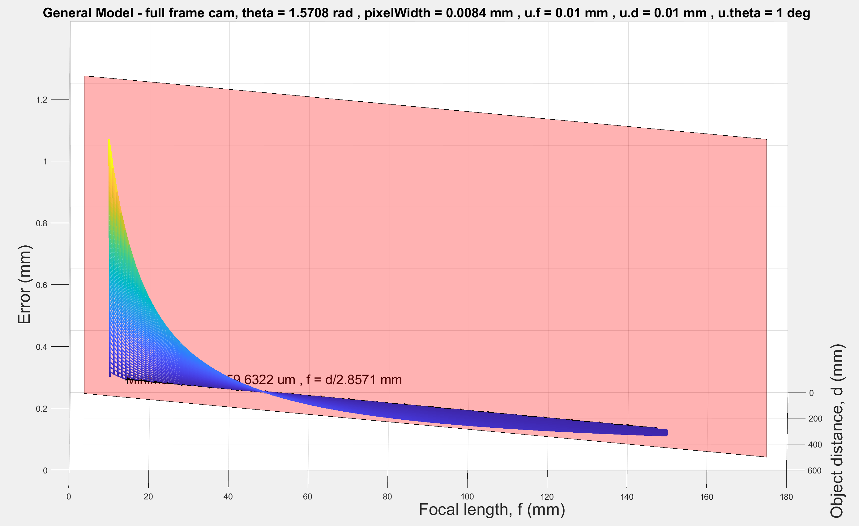

**Medium format** h = 44mm, pixelWidth = 5.3um, minError = 31.1538um

